# Assignment 4

**1. Loan Amortization Calculator**

**package oop.assignment4.Q1;**

package oop.assignment4.Q2;

public class Q2 {

public static void main (String[] args) {

CompoundInterestCalculator ci = new CompoundInterestCalculator();

ci.acceptRedord();

ci.calculateFutureValue();

}

}

package oop.assignment4.Q1;

import java.util.Scanner;

public class LoanAmortizationCalculator {

private double p ;

private double r;

private double n;

private double monthlyPayment;

private double amountPaidOverLoan;

public double getP() {

return p;

}

public void setP(double p) {

this.p = p;

}

public double getR() {

return r;

}

public void setR(double r) {

this.r = r;

}

public double getN() {

return n;

}

public void setN(double n) {

this.n = n;

}

void acceptRecord() {

Scanner sc = new Scanner(System.***in***);

System.***out***.println("Enter Principal Amount: ");

double principal = sc.nextDouble();

setP(principal);

System.***out***.println("Enter Intrest Rate : ");

double intrest = sc.nextDouble();

setR(intrest);

System.***out***.println("Enter Term : ");

double term = sc.nextDouble();

setN(term);

}

void calculateMonthlyPayment(){

double monthlyIntrestRate = r/(12*100);

int numberOfMonths =(int) n*12;

monthlyPayment = p*(monthlyIntrestRate * Math.*pow*((1+monthlyIntrestRate),numberOfMonths) )

/ ( Math.*pow*(1+monthlyIntrestRate,numberOfMonths)-1);

amountPaidOverLoan = (monthlyPayment*numberOfMonths) + p;

}

void printRecord() {

System.***out***.printf("Monthly payment: %.2f \n", monthlyPayment);

System.***out***.printf("Total amount paid over the life of the loan :%.2f ", amountPaidOverLoan);

}

}

Output:

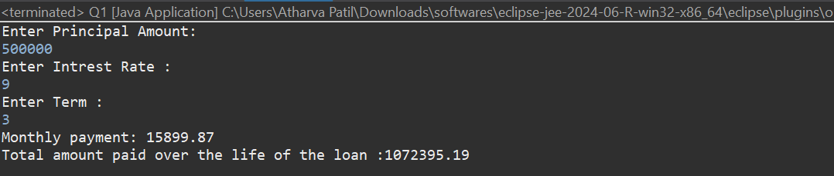

**2. Compound Interest Calculator for Investment**

Code:

File1 :

package oop.assignment4.Q2;

public class Q2 {

public static void main (String[] args) {

CompoundInterestCalculator ci = new CompoundInterestCalculator();

ci.acceptRedord();

ci.calculateFutureValue();

}

}

File 2:

package oop.assignment4.Q2;

import java.util.Scanner;

class CompoundInterestCalculator{

double p;

double r;

int n;

int t;

public double getP() {

return p;

}

public void setP(double p) {

this.p = p;

}

public double getR() {

return r;

}

public void setR(double r) {

this.r = r;

}

public int getN() {

return n;

}

public void setN(int n) {

this.n = n;

}

public int getT() {

return t;

}

public void setT(int t) {

this.t = t;

}

void acceptRedord(){

Scanner sc = new Scanner(System.***in***);

System.***out***.print("Enter Principal amount : ");

double principal = sc.nextDouble();

setP(principal);

System.***out***.print("Enter Annual Intrest Rate : ");

double intrest = sc.nextDouble();

setR(intrest);

System.***out***.print("Number of times the interest is compounded per year : ");

int numberoftimecompound = sc.nextInt();

setT(numberoftimecompound);

System.***out***.print("Enter Term : ");

int term = sc.nextInt();

setN(term);

sc.close();

}

void calculateFutureValue(){

double amount = this.p * Math.*pow*((1 + (this.r/100) / this.t), this.n * this.t);

double intrestEarned = amount - p;

System.***out***.printf("Total value after "+n+" years : %.2f \n",amount);

System.***out***.printf("Intrest earned : %.2f",intrestEarned);

}

}

Output:

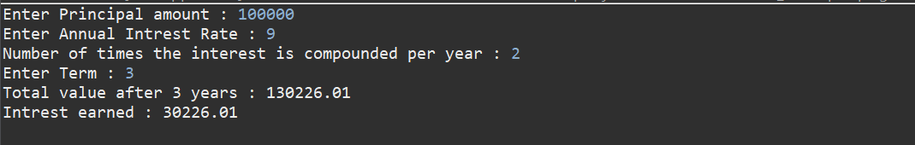

**3. BMI (Body Mass Index) Tracker**

package oop.assignment4.Q3;

public class Q4 {

public static void main(String[] args) {

BmiTracker track = new BmiTracker();

track.acceptRecord();

track.calculateBMI();

track.printRecord();

}

}

package oop.assignment4.Q3;

import java.util.Scanner;

public class BmiTracker {

float height;

float weight;

float BMI;

String result;

public void setHeight(float height) {

this.height = height;

}

public void setWeight(float weight) {

this.weight = weight;

}

public float getBMI() {

return BMI;

}

public void setBMI(float bMI) {

BMI = bMI;

}

public String getResult() {

return result;

}

public void setResult(String result) {

this.result = result;

}

void acceptRecord(){

Scanner sc = new Scanner(System.***in***);

System.***out***.print("Enter height (in meter): ");

float height = sc.nextFloat();

setHeight(height);

System.***out***.print("Enter weight (in Kg): ");

weight = sc.nextFloat();

setWeight(weight);

}

void calculateBMI(){

BMI = weight/(height*height);

setBMI(BMI);

if (BMI < 18.5) {

setResult("UnderWeight");

} else if (BMI >= 18.5 && BMI <= 24.9) {

setResult("Normal Weight");

} else if (BMI >= 25 && BMI <= 29.9) {

setResult("Overweight");

}else{

setResult("Obesity");

}

}

void printRecord() {

System.***out***.println("Bmi index: "+ getBMI());

System.***out***.println("Result: "+ getResult());

}

}

Output:

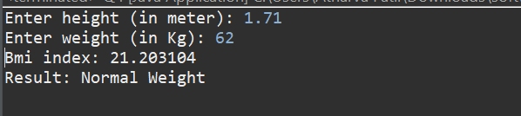

**4. Discount Calculation for Retail Sales**

package oop.assignment4.Q4;

public class Q4 {

public static void main(String[] args) {

DiscountCalculatorUtil cal = new DiscountCalculatorUtil();

cal.acceptRecords();

cal.calculateDiscount();

cal.printRecords();

}

}

package oop.assignment4.Q4;

import java.util.Scanner;

public class DiscountCalculatorUtil {

private double price;

private double discount;

private double discounted;

private double finalprice;

public double getPrice() {

return price;

}

public void setPrice(double price) {

this.price = price;

}

public double getDiscount() {

return discount;

}

public void setDiscount(double discount) {

this.discount = discount;

}

public double getDiscounted() {

return discounted;

}

public void setDiscounted(double discounted) {

this.discounted = discounted;

}

public double getFinalprice() {

return finalprice;

}

public void setFinalprice(double finalprice) {

this.finalprice = finalprice;

}

void acceptRecords() {

Scanner sc = new Scanner(System.***in***);

System.***out***.print("Enter Price: ");

price = sc.nextDouble();

setPrice(price);

System.***out***.print("Enter discount %: ");

discount = sc.nextDouble();

setDiscount(discount);

}

void calculateDiscount(){

discounted = (getPrice() / 100)*getDiscount();

setDiscounted(discounted);

finalprice = getPrice() - getDiscounted();

setFinalprice(finalprice);

}

void printRecords() {

System.***out***.printf("Discount: %.2f \n",getDiscounted());

System.***out***.printf("Final Amount: %.2f",getFinalprice());

}

}

Output:

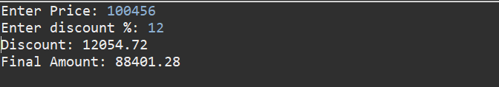

**5. Toll Booth Revenue Management**

package oop.assignment4.Q5;

import java.util.Scanner;

public class Q5 {

public static void main(String[] args) {

TollBoothRevenueManager manager = new TollBoothRevenueManager();

int choice;

do {

TollBoothManagerUtil.*menuList*();

Scanner sc = new Scanner(System.***in***);

choice = sc.nextInt();

switch(choice) {

case 1:

TollBoothManagerUtil.*setTollRates*();

break;

case 2:

TollBoothManagerUtil.*acceptRecord*();

break;

case 3:

manager.calcRevenue();

manager.totalVehicles();

TollBoothManagerUtil.*printRecord*();

case 4:

break;

default:

System.***out***.println("Enter valid value");

}

}while(choice != 4);

}}

package oop.assignment4.Q5;

import java.util.Scanner;

public class TollBoothManagerUtil {

static TollBoothRevenueManager *manager* = new TollBoothRevenueManager();

static Scanner *sc* = new Scanner(System.***in***);

public static void acceptRecord() {

System.***out***.println("Number of cars passed: ");

int carspassed = *sc*.nextInt();

*manager*.setCar(carspassed);

System.***out***.println("Number of trucks passed: ");

int truckspassed = *sc*.nextInt();

*manager*.setTruck(truckspassed);

System.***out***.println("Number of bus passed: ");

int Buspassed = *sc*.nextInt();

*manager*.setBus(Buspassed);

}

public static void setTollRates(){

System.***out***.print("Set Toll for car: ");

double carRate = *sc*.nextDouble();

*manager*.setCarRate(carRate);

System.***out***.print("Set Toll for Truck: ");

double truckRate = *sc*.nextDouble();

*manager*.setTruckRate(truckRate);

System.***out***.print("Set Toll for Bus: ");

double busRate = *sc*.nextDouble();

*manager*.setBusRate(busRate);

}

public static void printRecord() {

System.***out***.println("Total Vehicles: "+ *manager*.totalVehicles());

System.***out***.println("Total Revenue : "+ *manager*.calcRevenue());

}

public static void menuList() {

System.***out***.println("1. Set Toll Rates");

System.***out***.println("2. Accept Vehicle Records");

System.***out***.println("3. Display Total Revenue and Vehicle Count");

System.***out***.println("4. Exit");

}

}

package oop.assignment4.Q5;

import java.util.Scanner;

public class TollBoothRevenueManager {

int car;

double carRate;

int truck;

double truckRate;

int bus;

double busRate;

public int getCar() {

return car;

}

public void setCar(int car) {

this.car = car;

}

public double getCarRate() {

return carRate;

}

public void setCarRate(double carRate) {

this.carRate = carRate;

}

public int getTruck() {

return truck;

}

public void setTruck(int truck) {

this.truck = truck;

}

public double getTruckRate() {

return truckRate;

}

public void setTruckRate(double truckRate) {

this.truckRate = truckRate;

}

public int getBus() {

return bus;

}

public void setBus(int bus) {

this.bus = bus;

}

public double getBusRate() {

return busRate;

}

public void setBusRate(double busRate) {

this.busRate = busRate;

}

public int totalVehicles() {

return this.car+this.bus+this.truck;

}

public double calcRevenue(){

return (this.car*this.carRate)+(this.truck*this.truckRate)+(this.bus*this.busRate);

}

}

Output:

